INSTRUCTIONS: See the Portfolio Guidelines for full instructions. Choose one activity from each of the eight portfolio sections. Paste the activity number/letter and question text for each of the eight portfolio sections below as indicated in the example.

Double click on the page header (at the top right corner of this page). Replace the existing text with your first and last name. Replace the text in the 3rd line with the date. This process will place this information on all the pages of your portfolio.

Remove instructions (above) and example box (below). Replace Latin text with your submission. Repeat this process for each portfolio activity.

Leave reviewer instructions and feedback form as the final page.

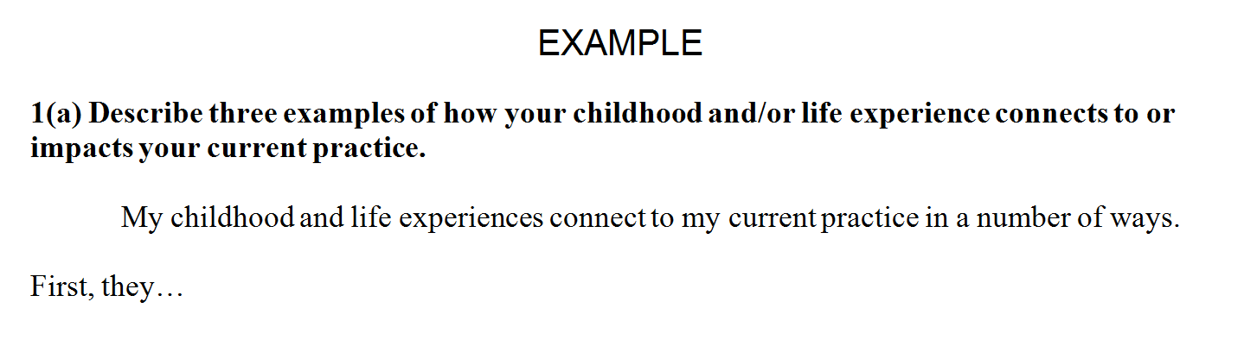

ENTER PORTFOLIO ITEM NUMBER AND LETTER HERE WITH THE TEXT OF THE QUESTION (as in example above).

ENTER RESPONSE HERE. Lorem ipsum dolor sit amet, consectetuer adipiscing elit. Maecenas porttitor congue massa. Fusce posuere, magna sed pulvinar ultricies, purus lectus malesuada libero, sit amet commodo magna eros quis urna. Nunc viverra imperdiet enim.
Fusce est. Vivamus a tellus. Pellentesque habitant morbi tristique senectus et netus et malesuada fames ac turpis egestas. Proin pharetra nonummy pede. Mauris et orci. Aenean nec lorem. In porttitor. Donec laoreet nonummy augue.
Assessment Form
Each portfolio is reviewed by two assessors and is approved if each section is assessed as ‘meets criteria’ as listed in the portfolio guidelines. If a section does not meet criteria, the assessor’s comments are returned to the candidate for revision and resubmission.

Assessments are confidential and may not be discussed or distributed to anyone not directly involved in the assessment process.

Instructions

- Enter name of assessor and date below.
- Enter item letter (i.e., a, b, c) selected by candidate for each section.
- Assess each item in the portfolio based on the criteria listed in the portfolio guidelines.
- Mark each item [x] as meets/does not meet criteria on the form below. If the assessment ‘does not meet criteria’, include information on modifications needed to ‘meet criteria’.
- Return the assessment to the CYCCB Office within 10 working days of receipt.

Assessor name:

Date of assessment:

Section | Item | Meets criteria | Does not meet criteria | If does not meet criteria, what additional information or modifications are needed?
1 |  | [ ] | [ ]
2 |  | [ ] | [ ]
3 |  | [ ] | [ ]
4 |  | [ ] | [ ]
5 |  | [ ] | [ ]
6 |  | [ ] | [ ]
7 |  | [ ] | [ ]
8 |  | [ ] | [ ]

General comments:

